Character: Superhero Mordecai

Backstory: Mordecai grew up in the Nantonda Swamp on Yoshi Island. One day, he stepped on a glowing, sparkly magic spider and suddenly got superpowers! By age 18, he left the swamp to go to the Double Chin Castle and stopped the “67” kids from breaking in. Now, he’s really powerful and he’s one of the most important main characters in the story.

Skills:
- His fingers can shoot bright red energy blasts (strong enough to knock over big rocks!)
- He can fly like a heron and run super fast.
- When bad guys come, he can make a super stinky smell to scare them away.

Strengths:
- He is super smart! He always thinks of good ideas for tricky situations.
- He never gives up, even under a tough situation.

Weaknesses:
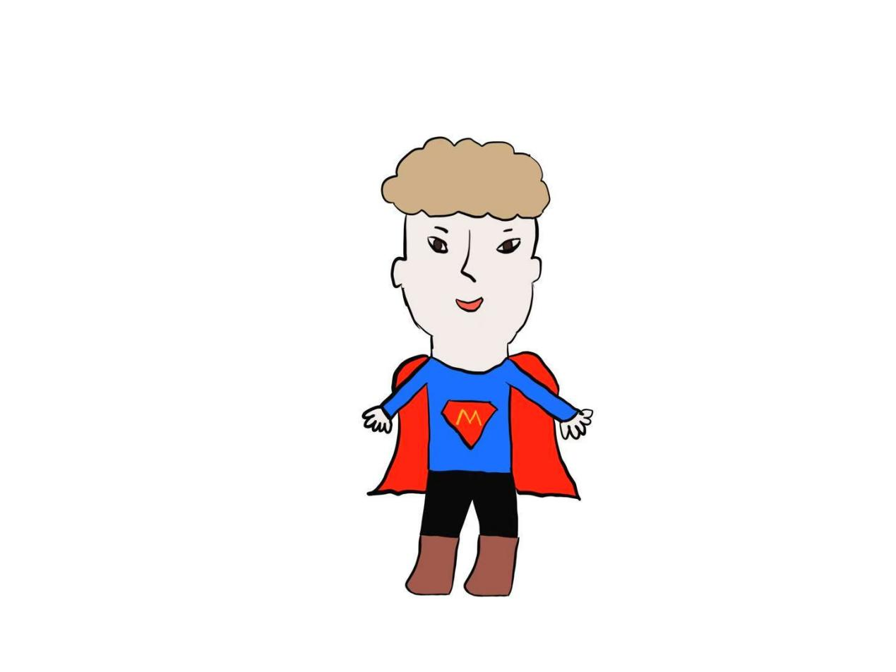
- He gets really mad if someone teases his shortcomings or argues with him
- His feet always smell terrible (yuck!) --the swamp mud got stuck in his skin before he got powers. So he wears big and thick boots everywhere.

